Conducting a spatial join in ArcGIS
- Make sure data is clean
- Select the option of Spatial Join in Analysis Tools (Analysis tools-overlay-spatial join)
  - Select target features: dataset
  - Select join features: Neighborhoods_SC_2012 feature class
  - Output=joined data
    - Have option of 1:1 join, keep all target features, intersects (default settings)
    - Can also change parameters of the spatial join: one to many or within
    - Click okay, have it build new feature class
- In the attribute table of the new joined shapefile, you will see that each entry has a Neighborhood listed next to it.

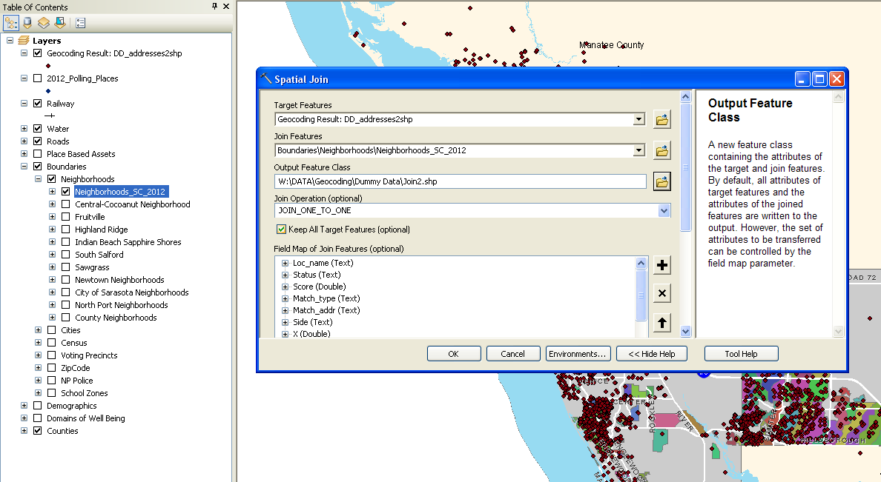

To create a summary for the counts (of points) in each neighborhood:
- With the attribute table open, highlight the Neighborhood field. Right click and select the “Summarize” option.
- A dialog box will appear giving you the option to select a field to summarize. Simply select the Neighborhood field, choose the location and name for your output table. Make sure you save as a dBASE table (under file type).Click OK.
- Voila: you have created a spreadsheet with the list of counts for the points each neighborhood. Save as an.xlsx file and you’ve got a table to join with your map.

